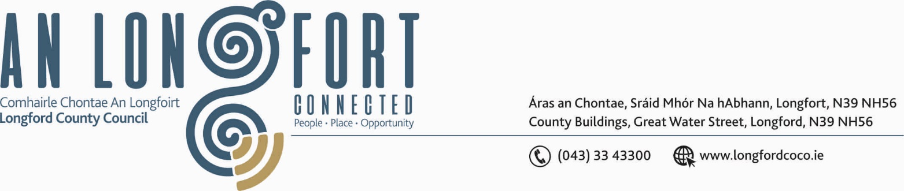

BALLYMAHON MUNICIPAL DISTRICT

Please note meeting will be held via Microsoft Teams.

22nd January 2021.

To: Each Member of Ballymahon Municipal District.

Dear Member,

You are requested to attend Meeting of Ballymahon Municipal District to be held
via Microsoft Teams on Thursday, 28th January 2021 at
4.00 p.m. to transact business, as set out on the Agenda hereunder.

Yours sincerely,
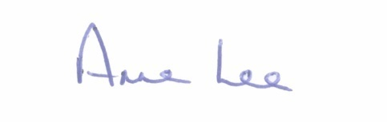

_______________
Anne Lee,
Meetings Administrator.

AGENDA

Prayer before meeting.

1. Confirmation of Minutes of Ballymahon Municipal District Meeting held on the 26th November 2020 – copy enclosed.

2. Matters arising from Minutes.

3. Declaration of Interest by Members.

4. Management Report - enclosed.

5. R392 Forgney Realignment. Route Corridor Options Public Consultation.
Briefing of the elected Members prior to the commencement of the Route Options Public Consultation – further information will be forwarded via post.

6. Consideration of Adoption of Part 8 Report (Planning and Development Act 2000 (as amended) and Planning and Development Regulations 2001) (as amended) in respect of the development of The Yard Village Hub, Abbeyshrule, Co. Longford - details attached.

7. Consideration and adoption of Draft Municipal District Report for inclusion in
Longford County Council 2020 Annual Report – enclosed.

8. Request received from The Irish Cancer Society to light up landmarks and public buildings yellow on the 26th March 2021 - Annual Daffodil Day – to heighten awareness of Daffodil Day Campaign – correspondence enclosed.

9. Notices of Motions, submitted by Councillors, as listed hereunder –

Councillor Paul Ross.

“That Longford County Council seeks funding to install a footpath/Cycleway from Carrickboy Village to Ballycloughan Village to connect these two integrated communities.”

“That Longford County Council seeks to connect the Ardagh Mountain walk down to Garrycam and into Drumming, Ballycloughan and connect back to Ardagh village by the Lyanmore Road. This would provide a fabulous tourist attraction for the area.”

Councillor Mick Cahill.

“That Longford County Council considers the provision of additional car parking to facilitate the increasing use of Newcastle woods for recreation.”

Councillor Pat O’Toole.

“I call on Longford County Council to include the Willow Crescent Estate in Ballymahon (16 houses) for a complete retrofit as part of the Just Transition Fund 2021.”

“I call on Longford County Council to erect public lighting on a stretch of the Royal Canal from Longford Bridge to Brannigan Harbour this loop from Ballymahon Mart to Brannigan and back to town via the Longford Bridge is very popular with walkers and cyclists and public lighting would greatly enhance this facility.”

Councillor Colm Murray.

“I call on Longford County Council to carry out emergency drainage works at the entrance to Abbeyderg Cemetery. Water and other substances are seeping from land in front of the cemetery and is depositing on the roadway at the gate to the graveyard. It has at times flowed into the cemetery and is a hazard for all road users.”

